https://sourcemaking.com/design_patterns/bridge

Before Bridge Design Pattern
Requirement1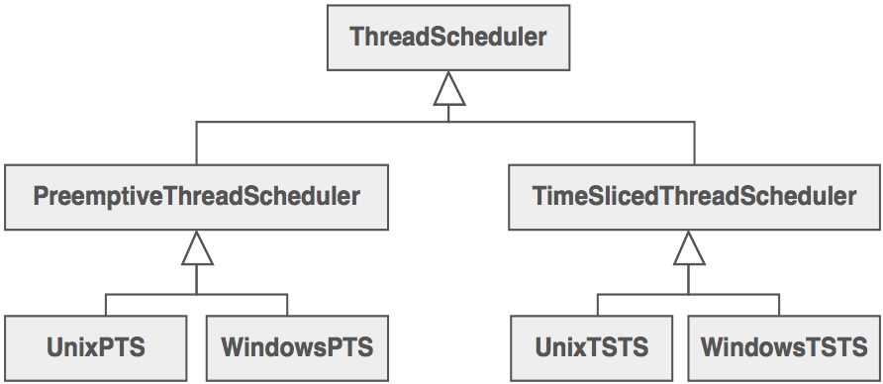
Requirement2

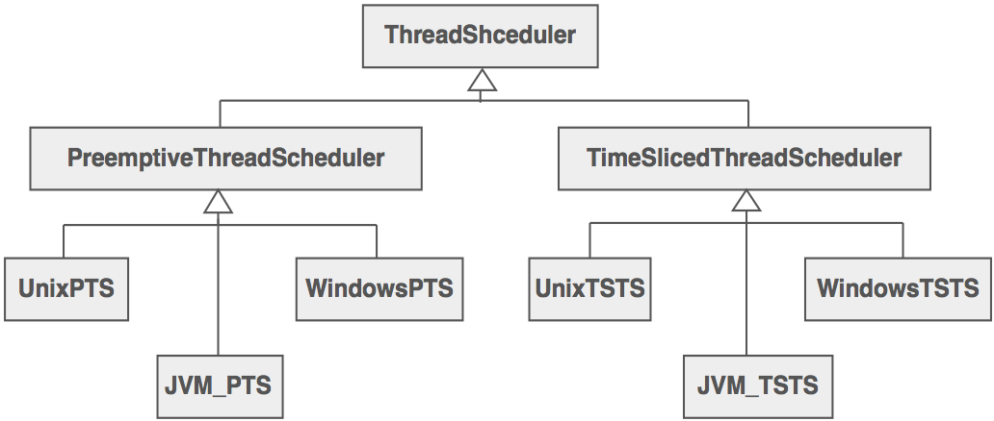

After Bridge Design Pattern
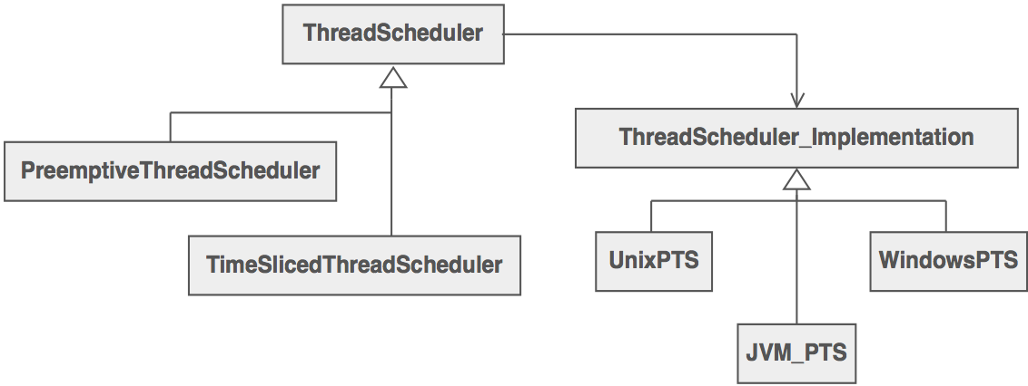

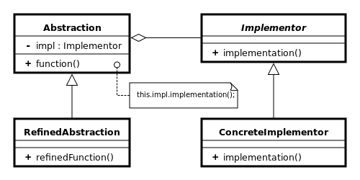

The adapter design pattern helps it two incompatible classes to work together. But, bridge design pattern decouples the abstraction and implementation by creating two different hierarchies.

